- GET request :-
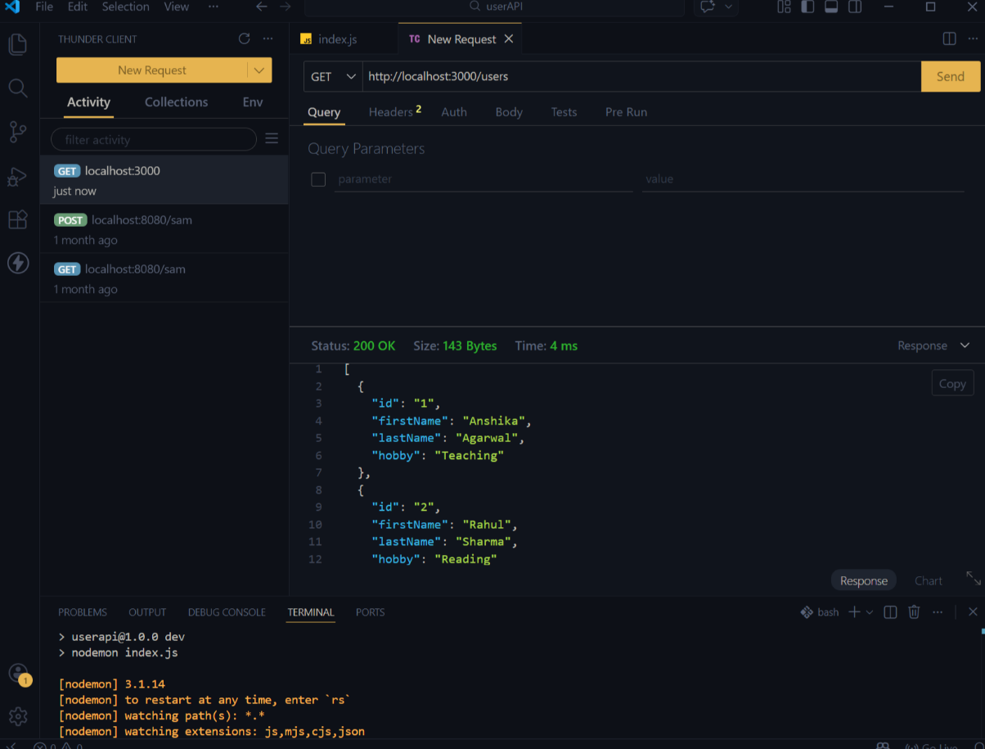

- GET request id:-
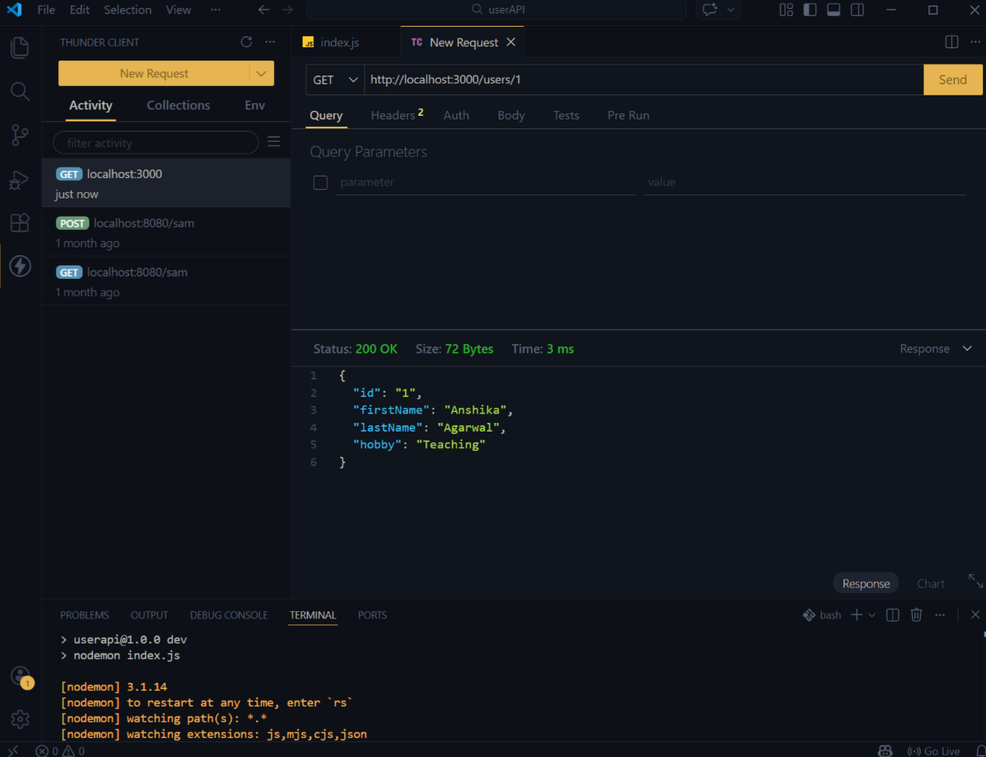
- GET request with invalid id to show 404 error:-
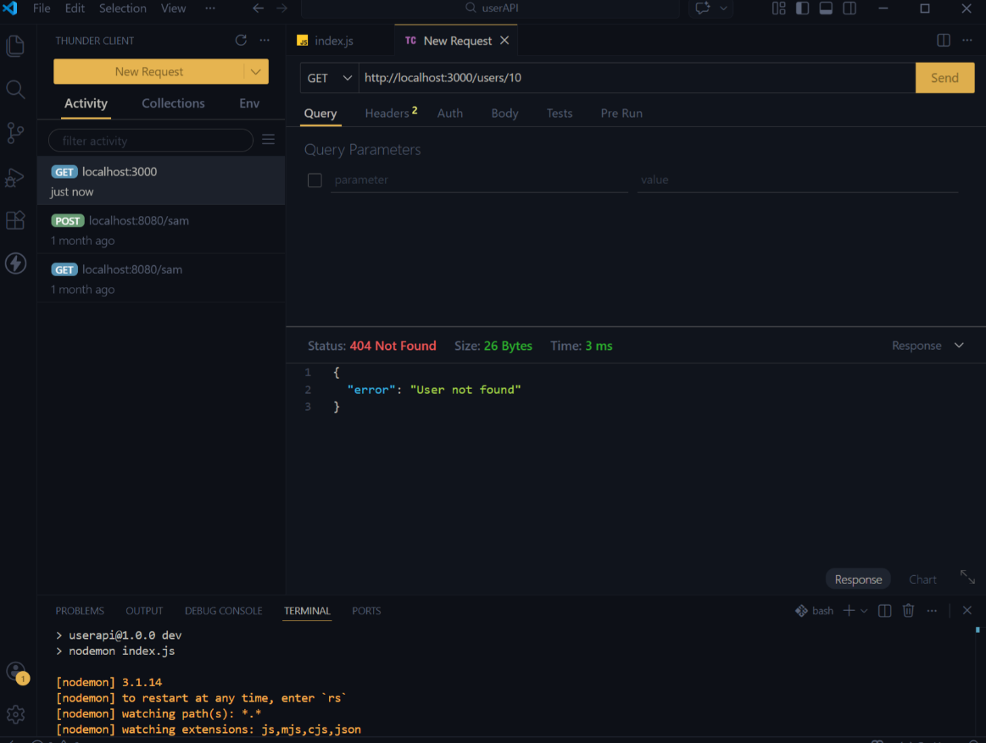

- POST to add new user : -
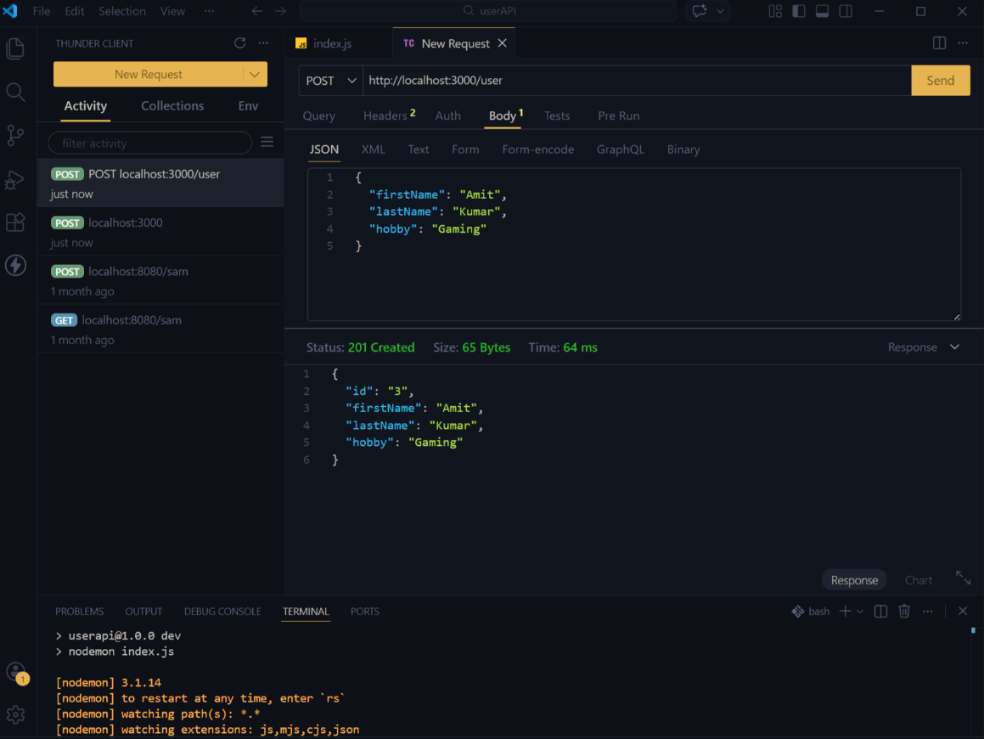

- POST invalid user entry:-
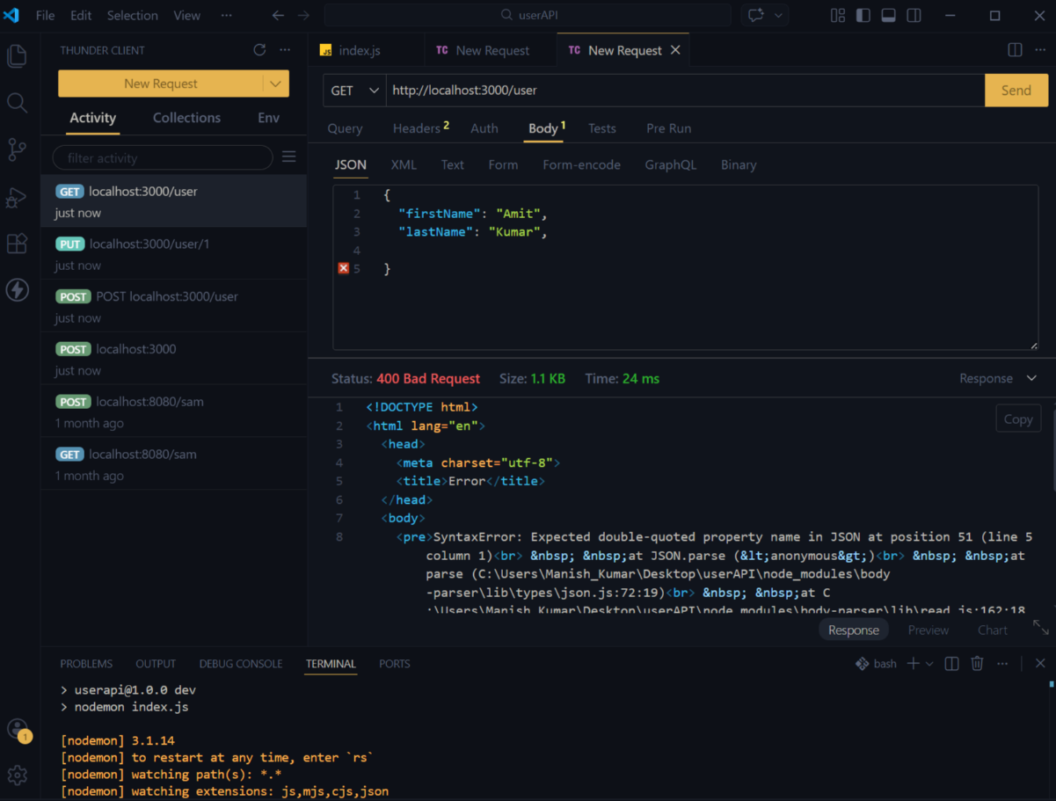

- PUT to successfully update:-
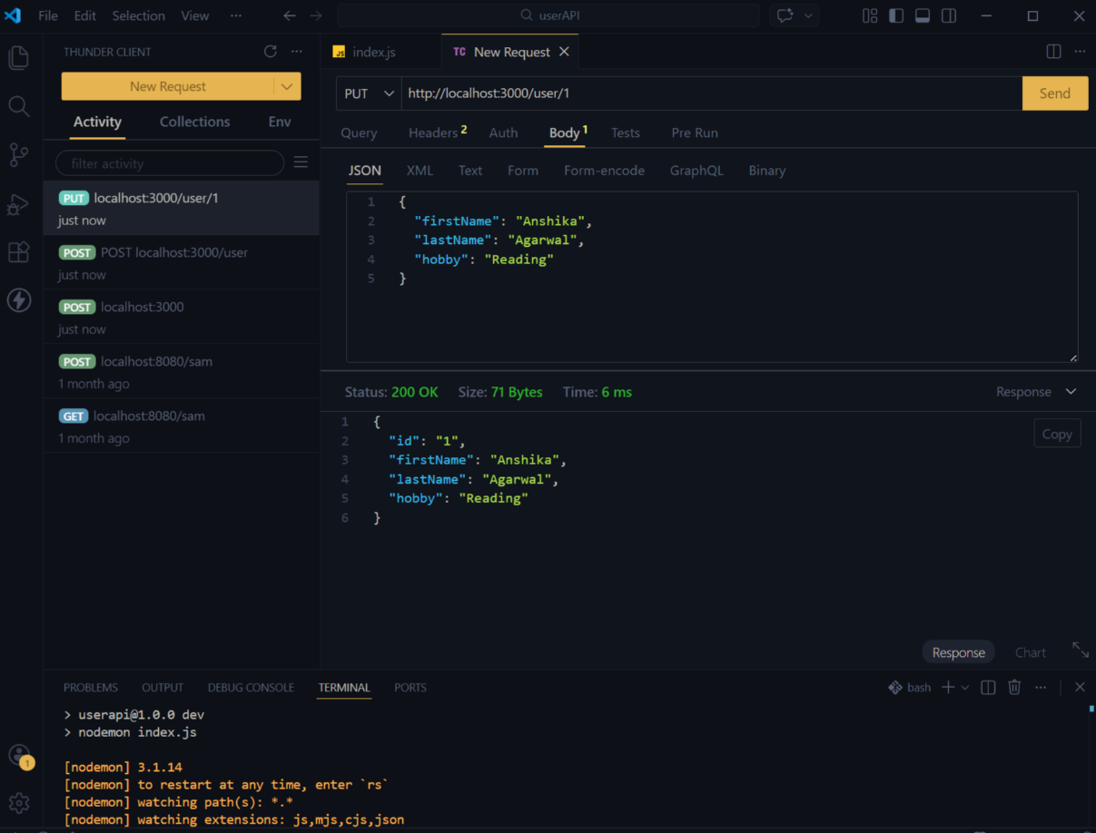

- PUT Invalid Update – User Not Found (Status 404):-
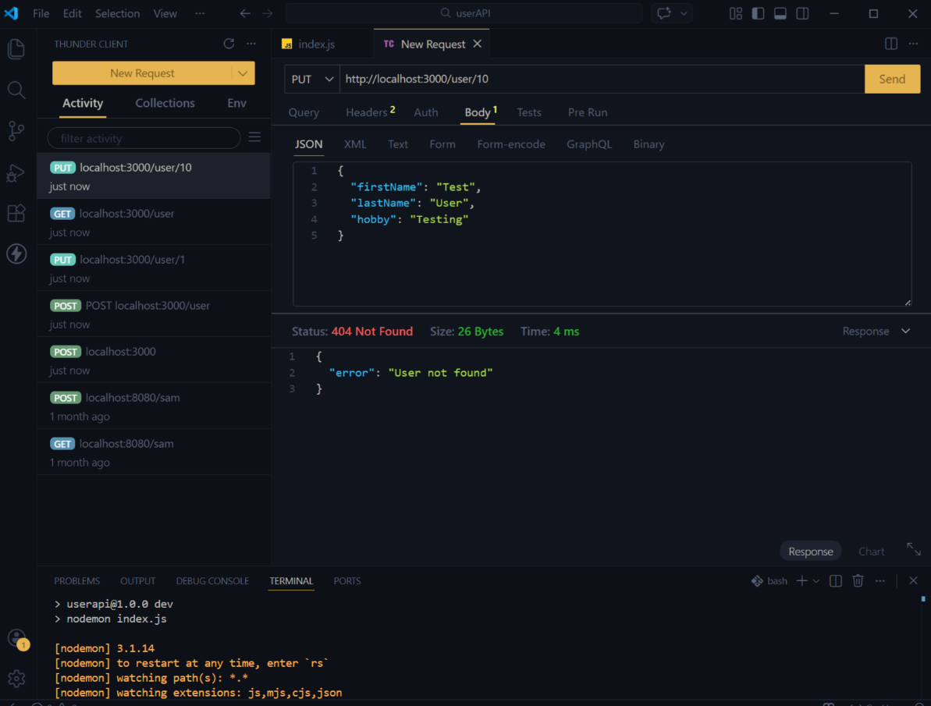

- DELETE - Successful Deletion (Status 200):-
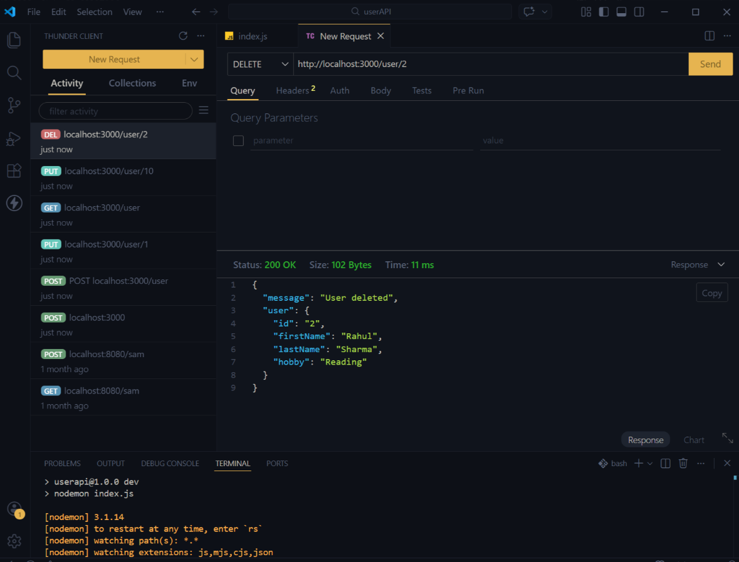
- DELETE: Deleting a Non-Existing User (Status 404):-
